1. Play on display GIF or JPG text, this msg triger by python scrypt
2. Make screensaver JPG or GIF pucture ( 1~5 pcs picture to change) time between picture or start screensaver must be configurable in config file, Screensaver must have option enable/ disable
3. Software must after reboot start automaticly and be in full screen
4. Font, size of letter, letter color, becground color, becground image(gif/jpg) must bi configurable
5. orientation must be configurable

DESIGN OF DISPLAY

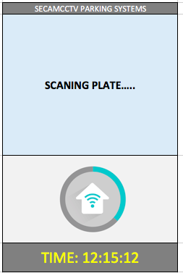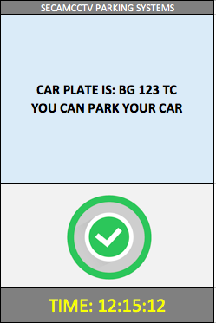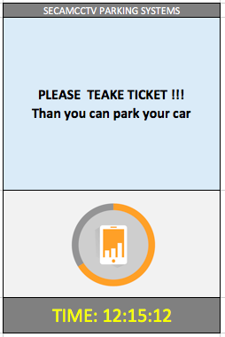

ORIENTATION

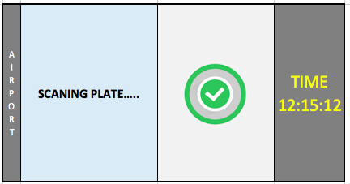

**Config file must have:**

* adjust the window size and dimensions betwin windows
* setup orientation
* Font (ARIAL BOLD) fixed,
* Font size per box global
* Font colorl per box global
* becground color per each box global
* Add image (gif/jpg) per each msg.
* Setup what is (fixed text box)
* Setup what is (Msg. box)
* Setup what is (image box)
* Setup what is (clock box)

|  |  |  |  |
| --- | --- | --- | --- |
| fixed text box | Msg. box | image box | clock box |

* Screansaver img folder
* Setup Screansaver on/off
* Setup Screansaver start time
* Setup Screansaver time between images